POWER LINE COMMUNICATION

* INTODUCTION:

Power Line Communication (PLC) is a communication technology that enables sending data over existing power cables. This means that, with just power cables running to an electronic device (for example) one can both power it up and at the same time control/retrieve data from it in a half-duplex manner.

PLC is like any other communication technology whereby a sender modulates the data to read it. The major difference is that PLC does not need extra cabling, it re-uses existing wiring. Considering the pervasiveness of power lines, this means with PLC, virtually all line- powered devices can be controlled or monitored!

* DESCRIPTION :

When discussing communication technology, it is often useful to refer to the 7-layer OSI model. Some PLC chips can implement only the Physical Layer of the OSI model, while others integrate all seven layers. One could use a Digital Signal Processor (DSP) with a pure software realization of the MAC and an external PHY circuit, or an optimized System-on-Chip (SoC) solution, which includes the complete PLC – MAC and PHY. The Cypress CY8CPLCXX series is an example of the latter, with a ready-to-use Physical and Network layer, and a user-programmable application layer. Before moving on to the applications of PLC, let’s first understand the various aspects of the Physical layer by viewing it as three segments on the basis of data rate.

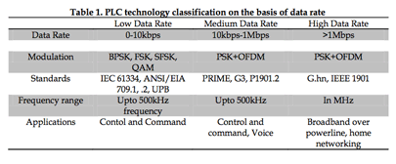

* Modulation Schemes: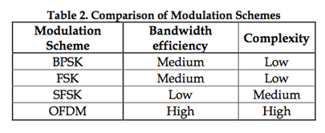

A variety of modulation schemes can be used in PLC. Some of these are Orthogonal Frequency Division Multiplexing (OFDM), Binary Phase Shift Keying (BPSK), Frequency Shift Keying (FSK), Spread-FSK (S-FSK) and proprietary schemes too (for example Differential Code Shift Keying (DCSK) from Yitran). In the table below, BPSK, FSK, SFSK and OFDM are compared on the basis of two important criteria – bandwidth efficiency and complexity (cost).

OFDM in particular offers high data rates, but requires computational horsepower to churn out Fast Fourier Transforms (FFT) and Inverse-FFT (IFFT), as required by the scheme. On the other hand, BPSK, FSK are robust and simple but offer lower data rates. The current trend is to move towards OFDM with PSK modulation (G3 and probably P1901.2). Such heavy computation will require DSP capability, whereas FSK, PSK and SFSK can be accomplished by a microcontroller.

* COMPONENTS:

1. FSK MODULATOR
2. TRANSFORMER
3. PROTECTION CAPACITOR
4. FSK DEMODULATOR
5. POWER LINE

* FSK MODULATOR

FSK modulation assigns different frequencies to each information signal status. On the receiving side it is passed through a circuit that determines differences in the frequency of the received signal and obtains the original information signal.

FSK uses a modulator to shift the frequency of the carrier wave proportionally to the level of the digital signal, which is the information signal. However, a digital signal has only two statuses, 0 and 1, and so a high frequency F1 is assigned to signal 1 and a low frequency F0 is assigned to signal 0 in relation to the center frequency Fc of the carrier wave.

The figure below is the system for switching the transmitter according to the modulating signal level. If the switching timing in the synchronization and modulating signal of the two oscillators is not good, the continuity of the phase between bits cannot be maintained as shown in the figure, resulting in an unnecessary spectrum that is not in fact used. The out-of-band unnecessary spectrum interferes with adjacent channels, and this spectrum is called a spurious emission. Spurious emission are undesirable from the point of view of effective utilization of radio waves and they are regulated by the Radio Act.

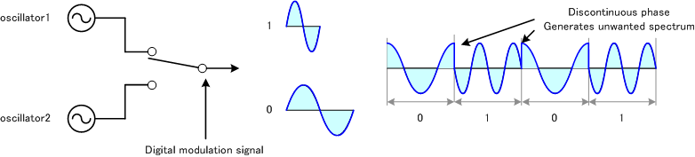

Here we can use XR2206 IC for modulation purpose.

Modulator Circuit Diagram:

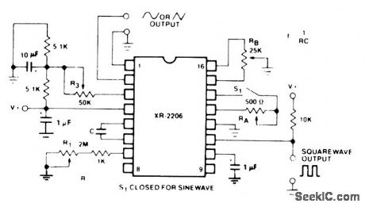

* TRANSFORMER

Here we use 230V to 12V transformer for superimposing power signal and fsk modulated signal.

* Protection Capacitor

Here we can use 100nF 400V capacitor for protection purpose. For this capacitor 50hz signal can easily block and the data singnal(10-20khz) can easily flow through it.

* HIGH PASS FILTER

We used 2nd order hingh pass filter for retrieving modulated signal from the superimposed signal. The cutoff frequency of this filter is 10khz and gain is 1.59.

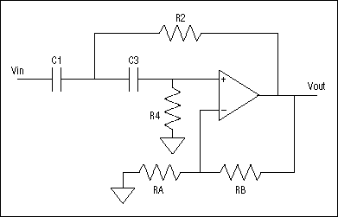

* FSK DEMODULATOR

We use FSK modulator for long distance communication, which the voltage level of digital signal has been converted to frequency. Therefore, at the receiver, we have to recover the FSK signal to digital signal that means the frequency should be converted back to voltage. We use phase locked loop (PLL) as FSK demodulator. PLL is a kind of automatic tracking system, which is able to detect the input signal frequency and phase. PLL is widely used in wireless applications, such as AM demodulator, FM demodulator, and frequency selector and so on. In the digital communications, various types of digital PLLs are developed. Digital PLL is very useful in carrier synchronization, bit synchronization and digital demodulation.

Frequency-shift keying is a type of digital binary communication technique. It is identical to FM modulation using a digital binary signal as the message m(t). Thus, a binary 1 represents one frequency, and a binary 0 represents another frequency. The FSK signal deviates from the carrier frequency depending on the binary message m(t). For example, assume m(t) can take on the values 1 or -1. When m(t) = 1, the FSK signal would deviate on the lower side of the carrier frequency. When m(t) = -1, the FSK signal would deviate to the higher side of the carrier frequency.

Here we used XR2211 IC for demodulation of modulated signal.

Circuit Diagram:

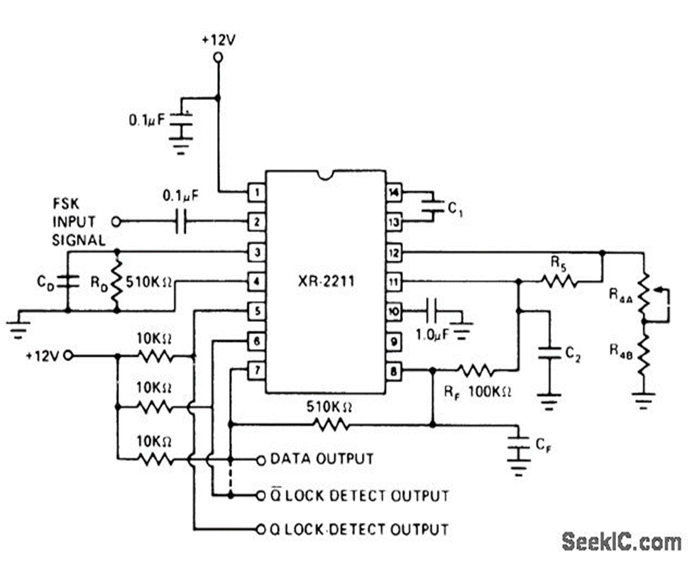

* Power line

We used 230V 50hz normal power distribution line for data and also power transmission simultaneously.